Selections from The Formularies of Angers and Marculf
A translation with notes
History 1030 Final Project
Jane Jacoby
Prof. Conant

What follows are selections from two Merovingian formulae, or legal handbooks, collections of template-like documents written to guide others to structure similar documents. They reveal aspects of daily life rarely included in more traditional textual sources like contemporary histories or literary texts, in which the goings on of ordinary people may have been perceived as trivial. Neither Marculf, the author of one of these two formulae, nor the various authors of the Formulae Andevavenses, or Formularies of Angers, ever tried to avoid potentially banal topics like disputes over vineyards or divorce settlements. But neither did these works gloss over the dark realities of their time—both include documents touching on murder, slavery and rape.
The translation and interpretation of these particular documents pose several problems. The Latin itself is often difficult to parse, since the vocabulary and grammar differ from that of classical Latin. But this can make the documents all the richer, for they present a snapshot of a dynamic vernacular Latin that continued to be spoken as a lingua franca throughout Europe. This occasionally creates difficulties for the translation. My translation also suffers from working off of a much later transcription, in this case a version of the Formvlae Merowingici et Karolini Aevi, edited by Karl Zeumer in 1886, which appeared in the Monumenta Germaniae Historica. The Monumenta is a well regarded source for primary documents, but working from any edited source can add to potential inaccuracies. Unfortunately, the few images of the manuscripts that are available are even more problematic—compare the first few lines from the image of the manuscript (included on the final page) to Zeumer’s text, which reads “domino ac reverentissimo pape Landerico Marculfus, ultimus ac vilissimus omnium monachorum.” The manuscripts are themselves imperfect records, especially with the Angers Formularies, since they were copied by various scribes over a period of some two hundred years, and not always together. The profusion of spelling differences and grammatical confusions often within one sentence show that these scribes may have had a less than perfect grasp of the words they were copying. The concept of a formulary itself creates complications—how can one interpret situations when no specifics are given? How many of these relate to common events, and how many to the unusual? Questions of context thus plague the understanding of these texts. They are, nevertheless, exceedingly compelling, and so worth the trouble.
I have chosen to translate sections of these two texts on the issues that take up the majority of space in both, detailing the position of the ecclesiastical and political elites as well as those dealing with more bizarre or dire subjects. I have also included the remarkable introduction of Marculf and the start of his capitula or “little headings,” since they stand out as noteworthy markers of this text’s singular author, and are rare in works of this type. Since I wrote the original translation near Christmas, I have also included a nativity greeting.
From the Formulae Andecavenses:
The Formulary of Angers is considered the oldest surviving legal formulary. It is a collection of separate documents whose origin seems to be the city of the Angers in what is now western France. These documents, written not by one author, but over the course of potentially two hundred years, relate to mostly local events.

In the name of Christ these documents begin.
No. 2. This is an act of sale, for him who is selling himself.
To my lord A and also his wife B, from I, C. Because my negligence conspired to cause me to steal your goods, and I am unable to accomplish this in any other way, except the following; in order to appease you I am to give my complete status [of freedom] to your service; so that it is clear, before you I bind my [free] status to your service without injunction, but in fact fully out of my free will, albeit owing to the fact that my falsehood is evident. I am giving myself to you for the price of D solidi, which is agreeable to me, so that whatever from today on you should wish to do with me in all things you may go forth with the power of executor, just as with the rest of your obedient slaves obtained by sale, with God’s favor. If I myself or some of my kin or people from wherever and not of my household should take steps against the enacting of this sale, which I with good will asked to be made, let him commit himself with a solemn pledge some E solidi, to be divided between you and the royal purse, and may he be unable to lay claim to what he seeks, and may this sale and my will stay firm.

No. 26. So commences a guarantee of security
When a case has been previously decided, for example some woman named A deliberately levied an accusation of rape against a man of the Saint B named C, of which she was herself the victim, and it was settled that he would have to make an agreement with the woman herself out of her own free will, which accordingly he did. Whence it was unanimously decided that if the man furthermore were to receive a letter made firm by her hand, which accordingly he also did, that, if the woman herself after this day should wish to bring action against the man, she must deposit D solidi. The deed of security has been made.
From the Marculfi Formulae
This collection has the distinction of having “the reputation of being the archetypal formulary.” It is “the longest…, the best known, [and] the most studied.” Unlike the Formulary of Angers, this later collection had only one author, a 7th century monk named Marculf, possibly belonging to the order of St Denis, who was appointed the task by one Bishop Landeric. Marculf goes above and beyond what his patron asks for. This collection is of a much broader scope than Angers, detailing both quotidian and monarchical events, and has two innovations—the lengthy introduction, of a style and verbosity one would expect from a more literary work, and the table of contents.

In the name of God the preface of this book begins.
To the holy Lord, eternally worthy of most blessed and apostolic honor, receiving all praise and enduring glory, and to the most honored lord and bishop Landeric, from Marculf, the last and humblest of all monks. If only, dear father, I had the strength to follow your order as effectively as I wished, since the undertaking of this affair of yours to which I have been yoked since first entering it is now beyond my abilities, when I may stuff fully seventy years or more with living, and now my shaking hand is no longer fit for writing, nor my darkened eyes sufficient for seeing, nor my blunt senses equipped to thinking, because as a saying by certain most foreseeing men goes: in boys buds sense, in young men it blooms, in old men it ebbs. Therefore it is not possible for me to make this work eligant(sic), as I wished, however I made it orderly, as I am able, and [included] not only those [pieces] that you had ordered, but in truth even many others. My artless and rustic nature took pains to put as many peasant charters as royal precedents in like manner in this document. For I know there will be many, both you and other most wise and eloquent men, skilled at rhetoric and dictation, who this, if they were to read it, alas, having compared it against their good taste, would spurn as trifling and likewise nonsensical, and would certainly distain to read. But instead I am not before such men; to the contrary, I wrote for the initiation of boys, so I wrote as plainly and simply as I was able. Therefore, here are a considerable number of men’s affairs, as many from the Palatine Hill as from the country, about which no one else has been able to write until they were collected one after another; and only now can they be written about with words and acted upon with deeds alike. Truly, I took care to heap together into this one tome, as per the custom of this place, those things which men greater than I, with whom we live, acquainted me with, and also what I thought of out of my own senses, such as I was able, and I set down little headings, so that when a questioner wishes, he may easily find again a writing he had found before.

These little chapter headings begin this work.

- How one may establish prerogative
- The surrender by the king of this privilege
- The king’s immunity
- Establishing immunity from the king
- Document from the king about the office of a bishop
- A short letter from the king to a metropolitan bishop, so that he might consecrate another bishop.
- Agreement of the citizens in favor of an episcopate.
- Charter of a dukedom, position of a patrician, or countship.
- A short letter of recommendation to another king, when a diplomatic envoy is arranged and sends mere words
- The reply to the king through his counsel, etc.

I. 1. About Privilege
To the holy Lord and venerable brother in Christ abbot A or the whole congregation of the monastery of B place, in honor of the blessed him of C, having been built in the province of D, by bishop E. This is driven by our affection for your love, a burning ray from god, to provide for your peace those things which may remain our reward, and to define these things in a lasting way, through virtuous courses and with an undisturbed path, which with the approval of God may hold fast to strength; since future recompense from God is hoped for no less by he who lives in contemplation of his downfall than by he who in this present situation gives to the poor. And let no one judge us disparagingly, or determine that in this they discern a change of tune, when similar cases have been seen to stand firm from the time of antiquity; through the imperial order of pontiffs, the holiest of holy monasteries, Lérins, Agaune, and Luxeuil, or by innumerable measures throughout the whole kingdom of the Franks, under the privilege of freedom. But through reverence of the sainted, and fulfilling the mandates of all my brothers, having taken in wholly their advice, I unfold my obedience. We entrust that which genuinely you or your successors, advised by the Holy Spirit, may successively defend, and assuredly those sacred things which the bishop of the church of this province should need to fulfill, by including them [here]. This is, that a man of your congregation, who in your monastery should be responsible for [performing] the sacred services, a man whom the abbot with all of the congregation of B will have chosen, must receive wholly consecrated rites from us or from our successors, having first received no honorary gifts. The bishop himself shall bless the altar and sacred chrism in the aforesaid monastery each year, if they should wish to ask [for it]. In reverence of the place he shall depart without payment. And as divine supervision when the abbot from his own monastery to the lord will have flown, whom unanimously the whole congregation the monks of B will have chosen from themselves for his outstanding knowledge of the [monastic] Rule and a life being suited to service, without first the bishop of the city himself may memorably advance to abbot. And may none, neither of us nor our of succeeding bishops or archdeacons, nor of the rest of the orders, nor another person of the city, presume to have wholly some other power in this monastery, neither over its affairs, nor over arranging of people, nor over villas conferred by now or in some later time by a king as a gift or which may be granted by individuals, or the remaining property of the monastery. Nor let whoever dare to hope to take away tribute from this monastery as from parishes or other monasteries with a cause nor anything from this place, to which God fearing men have carried or offered on altars, or sacred scrolls or whatever sort of ornament, which concerns the apparel of divine adoration, these having been gathered by the present or in some later time. And unless asked by the congregation of that place or the abbot to celebrate the mass, may it not be permitted of us to approach the sanctitude or to proceed through the palisade of the monastery’s border. And if this pontiff was asked there for the celebration of mass or for their benefit draws near, to celebrate and to preform the divine mysteries, a simple and sober benediction having been taken, and having refused from them any gifts he may desire to have must return, so that monks, who are called solitary, quiet having been achieved, may be able to stay strong, with God as their guide, standing before time to exult and living under sacred rule and pursuing the lives of blessed fathers, so they may be fully able to entreat the lord for the position of the church and the health of the king of country, and if one or another of these monks have cooled to this conscientiousness or act otherwise, may they shortly be set straight by their abbot according to their rule, if they can; if otherwise, the pontiff of this city must use force, since, whatever may be imparted to the domestics of faith for the quiet of calm, nothing of canonical authority may be driven out. If any one of us, may God prevent this, having been moved by cunning or misled by cupidity, should presume to violate those things which are enumerated above with a rash spirit, having been thrown down by divine vengeance, may he be subjected to a curse of excommunication and for three years from the community of all brothers be known as a stranger, not the least so this privilege may remain perpetually unspoiled. Indeed, that our constitution may remain standing with enduring vigor, both we and our brothers of the lord bishops decided to confirm it with a signature by our hands. Conducted here on this day F, in this year G.

II. 16. If someone carries off an unwilling girl
To my sweetest wife A, from B. While I did not have us betrothed with the will of your parents, and against your or your parents desires I wickedly snatched [you] my wife by abduction, or; while, being arrogant, in opposition to the will of your parents I wickedly grabbed my wife through abduction, for which I put myself in danger to make such an attack. But through the intervention of priests and good men, I have been given my life, however in this way—that I should sanction through this letter of agreement what I had owed to give to you as the marriage gift or in the dowry document before our wedding day, if I had been betrothed to you, or if it is suitable, a surrendering of goods, which I might do to stay strong; which accordingly I also did. For that reason I give to you a place called by name C, situated in the province D, with houses suited for habitation, and all necessary and useful essentials, with land, with tenants, with E many slaves obtained by mancipium, with vineyards, woods, meadows, pastures and everything of service that remains, F many nags, G many oxen, with a herd of horse, a herd of cattle, a herd of pigs, a herd of sheep, with gold, silver, jewels, carpets worth H solidi. All this that is listed above having been bound on the present day I yield into your power and authority, for your possession: thereafter you, having free ability, may hold onto or do with it whatever you choose to. If someone truly, etc.

II. 45 A further item on the nativity of the Lord
Wanting to know the love of mutual happiness brought universally from heaven, without bounds, preferring to precede your clemency with letters, or your sanctity, with gifts given to you by your patron A, desiring with estimable and devoted care, that some note of your pious example should instruct us with what cheer you spent the feast of the nativity of the Lord. For word of the improved recovery of your health shall be a dear thing of abundance to us.
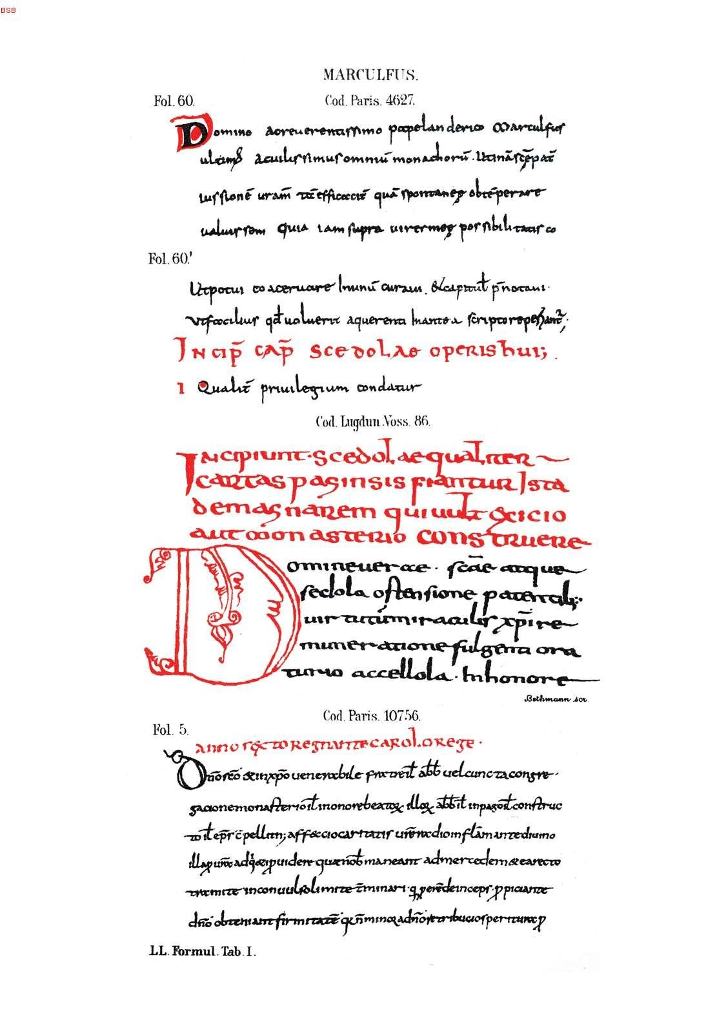
Bibliography
Primary Sources
Formulae Andecavenses, in Monumenta Germaniae Historica. Hanover, Germany: Societas Aperiendis Fontibus Rerum Germanicarum Medii Aeui, 1886. Last accessed December 8, 2014, http://goo.gl/PZJBz4.
Marculf. Marculfi Formulae, in Monumenta Germaniae Historica. Hanover, Germany: Societas Aperiendis Fontibus Rerum Germanicarum Medii Aeui, 1886. Last accessed December 8, 2014, http://goo.gl/0uejS2.

Secondary Sources
Lewis, Charlton T and Short, Charles. Harpers’ Latin Dictionary: A New Latin Dictionary Founded on the Translation of Freund's Latin-German Lexicon edited by E.A. Andrews. Oxford: Larendon Press, 1879. Last accessed December 8, 2014, http://www.perseus.tufts.edu/hopper/morph.
Niermeyer, J.F. Mediae Latinitatis Lexicon Minus: Lexique Latin Médiéval-Français/Anglais. Leiden : E.J. Brill, 1984.
M. D. Knowles, “Presidential Address: Great Historical Enterprises III. The Monumenta Germaniae Historica,” Transactions of the Royal Historical Society, Fifth Series, Vol. 10, (1960): 129-150. Accessed at http://www.jstor.org/stable/3678777
Rio, Alice. The Formularies of Angers and Marculf: Two Merovingian Legal Handbooks. Translated Texts for Historians. in Monumenta Germaniae Historica. Liverpool: Liverpool University Press, 2008.
Rio, Alice. "Charters, Law-codes and Formulae: The Franks between Theory and Practice." Frankland: The Franks and the World of Early Medieval Europe. Ed. Paul Fouracre and David Ganz. Manchester: Manchester UP, 2008. 7-27.
Saunders, Corinne J. "Classical Paradigms of Rape in the Middle Ages." Rape in Antiquity. Ed. Susan Deacy and Karen F. Pierce. London: Classical of Wales, 2002. Web.

Both collections contain documents focused on raptus, which I have translated as “rape.” The word raptus had broader implications in Medieval Europe. As C. Saunders points out in her essay, “Classical Paradigms of Rape in the Middle Ages,” raptus could describe “noncontractual marriage by abduction… with or without the woman’s consent” as well as “forced coitus”. Alice Rio, the author of the only recently published translation of these two Formularies, chooses not to translate raptus as rape, stating that it “can mean either ‘rape’ or ‘abduction,’ or even ‘elopement’ when it was done with the woman’s consent,” despite noting that in this context there clearly is no consent, and so the first is the “more probable” of the three. For more, see C. Saunders, and A. Rio’s works, cited below.
Since I am unfamiliar with Late Latin, I referred frequently to A. Rio’s excellent translation to avoid utter confusion.
“Formulae from the Merovingian and Carolingian ages.”
The Monumenta are a collection of primary sources focused on the history of early Germany and its neighbors, focusing on the era between 500 AD and 1500 AD.
Formulae Andecavenses, in Monumenta Germaniae Historica (Hanover, Germany: Societas Aperiendis Fontibus Rerum Germanicarum Medii Aeui, 1886). My best guess of “Domino doreuerenanimo poopelandemo mareulfur uloms aeulirnmurommū monachorū” is, with the exception of Domino, entirely gibberish.
As in Angers no. 26, where the number of the verb changes from singular to plural and back for no particular reason.
For more on the complications of the formulae and their context, see either of A. Rio’s works on this subject: the introduction to Formularies of Angers and Marculf or “Charters, law-codes and formulae: the Franks between theory and practice”.
Rio, The Formularies of Angers and Marculf, pp. 38-46
The word vindicio, “an act of sale”, like many other terms in these collections, does not exist in classical Latin, but takes its root from older words—in this case vendere, “to sell”, which is also used in this sentence.
There are several other documents in these two formularies on self-sale. In Angers no 3., the man’s punishment is even harsher than the one here—he is “tortured and convicted and could have been put to death.” (Rio, The Formularies of Angers and Marculf, pp. 51). For further examples, see Angers nos. 19 and 25, or Marculf II, 28.
These documents are intended for use as a “Mad-Libs” of the law—find the appropriate document, and simply fill in the blanks. In both Angers and Marculf, ille, “that”, is used as a placeholder for names, dates and locations. Following Rio’s lead, I have translated it as person A, date B, location C, etc., for perspicuity.
Not ille, but tantus, “so great,” which has the same space-holding purpose.
Gold coins of a roman style which continued to be minted into the Carolingian period.
There are many quirks of the language of these formularies. Often a word will seem to be the same as a classical one, with one letter off, as is the case here with vindecare, which I have taken to mean vindicare, “to assert a claim to.” Occasionally, the editor of the Formvlae Merowingici et Karolini Aevi will in his footnotes have suggestions for substitutions which I have heavily relied upon.
Aliqua, “some,” could be taken to be dismissive, but I would argue it is simply part of the generalized style of these documents, and in English could be used as akin to the indefinite article “a.”
Deberunt and facerunt, which seem to refer to the homine sancti illius, the accused man, are plural.
i.e. signed by her hand.
This document is clearly not intended to adjudicate on the case of rape, as it is stated that the case has gone not incognitum, that is “not untried,” but to avoid additional litigation. The absence of any record dealing with the original trial is interesting, as are the unnamed arbitrators who “unanimously decide” this case. See Rio, The Formularies of Angers and Marculf, p. 69.
Rio, The Formularies of Angers and Marculf, pp. 104.
There is no consensus with regards to the dating of Marculf, and of where and when this bishop Landeric was from. For a fuller discussion of the various arguments, see Rio, The Formularies of Angers and Marculf, pp. 107-117.
Marculf’s self-deprecating introduction may refer to the preface of Orosius’s History against the Pagans (see Uddholm, Formulae Marculfi: Etudes Sur La Langue et Le Style, p. 222), purposefully negating Marculf’s claims of ignorance.
Papa, now taken to mean the Pope of Rome, at this time implied simply “bishop” (see Rio, The Formularies of Angers and Marculf, pp. 125).
That is, since he is pushing seventy.
Marculf’s proverb is typical of the unexpected expressive language he uses throughout the formularies.
The use of eliganter rather than eleganter can be seen as an error, or if interpreted as a deliberate misspelling, as yet another example of his ironic efforts to belittle his work.
The word scedola is included in no dictionary that I checked. I have taken it to mean “document.”
I can see two potential interpretations of ut potui, “as I was able,” either that he is writing in the only way he is able, that is plainly, or that he is writing as plainly as he can. This confusion adds to the repeated and seemingly false modesty of the preface.
The centermost of the Seven Hills of Rome, i.e., from the lofty city.
The use of succiduis to mean “downfall” as it does here is a nice example of the Christianization of Latin during this period. Succiduis comes from the classical latin adjective succiduus, meaning “sinking,” but as a noun in this later period has connotations of one’s own death and judgment.
Literally, “new song”.
Three influential monasteries founded in the 6th century.
Oil used for anointment.
Here and elsewhere, ipse, “self,” has been translated as “this,” since the implication seems to be the selfsame or previously mentioned, and I feel “this” is a cleaner rendering.
The word civitas in classical Latin meant “citizenship”, but in later Latin comes to be synonymous with urbs, “city”. See Charlton T Lewis and Charles Short, Harpers’ Latin Dictionary: A New Latin Dictionary Founded on the Translation of Freund's Latin-German Lexicon edited by E.A. Andrews (Oxford: Larendon Press, 1879), last accessed December 6, 2014, http://www.perseus.tufts.edu/hopper/morph, s.v. “civitas".
i.e., servants
For more on the use of raptus and consent in the Medieval world, see note 1.
I.e., allowed to live.
This document, like many others in the collection, ends abruptly with et cetera, leaving the ending up to the interested party to fill in himself.
This document is the equivalent of the modern Christmas card. Since it refers to the clemency of the recipient, and asks after how he had spent his Noel, it appears to be a belated note to make up for tactlessly neglecting to send nativity greetings earlier. The addendum of “recovery” adds a “get well soon” spirit to the end.

